Storage Modes in Power BI

Power BI Lets you control the storage modes in Power BI Desktop. Storage Modes defines weather or not the Power BI desktop caches the data in In-memory for reports.

You Specify storage modes in following two ways :

* Specify Storage mode for whole dataset.
* Specify Storage mode for each dataset.

Storage mode provides the following advantages :

****Query performance****:

When user interacts with the visual , the DAX(Data analysis expressions ) are submitted to the dataset. By using the storage modes properly , you can cache data into memory , and increase the query performance.

**Large Datasets :**

Suppose you have a transactional table that has millions of data , that is too large and expensive to store in memory by using import data. You can use direct query storage mode. So in this way , you can specify which table is worth caching.

****Data refresh optimization****:

Data refresh time depends on the size of cache. The less data is cached ,the less time refresh will take.

You do not need to refresh the data that is not cached. You can reduce the refresh time by caching the data that is necessary to meet your business requirements.

**Types of Storage Modes:**

There are basically three types of storage modes :

**Import :** Import mode cache you data from data source to in memory cache .when you set submit a DAX query to power bi dataset , it will return you the result from the cached data.

To keep data updated you have to refresh you datasets accordingly.

**Direct Query :**

When you set storage mode to direct query data is not cached in your memory. When you submit a DAX Query , it will return the result by querying the data source directly.

**Dual :**

Tables with this setting can act as either cached or not cached, depending on the context of the query that's submitted to the Power BI dataset. In some cases, you fulfill queries from cached data. In other cases, you fulfill queries by executing an on-demand query to the data source.

## **Use the Storage mode property**

**Specify Storage mode for whole dataset**

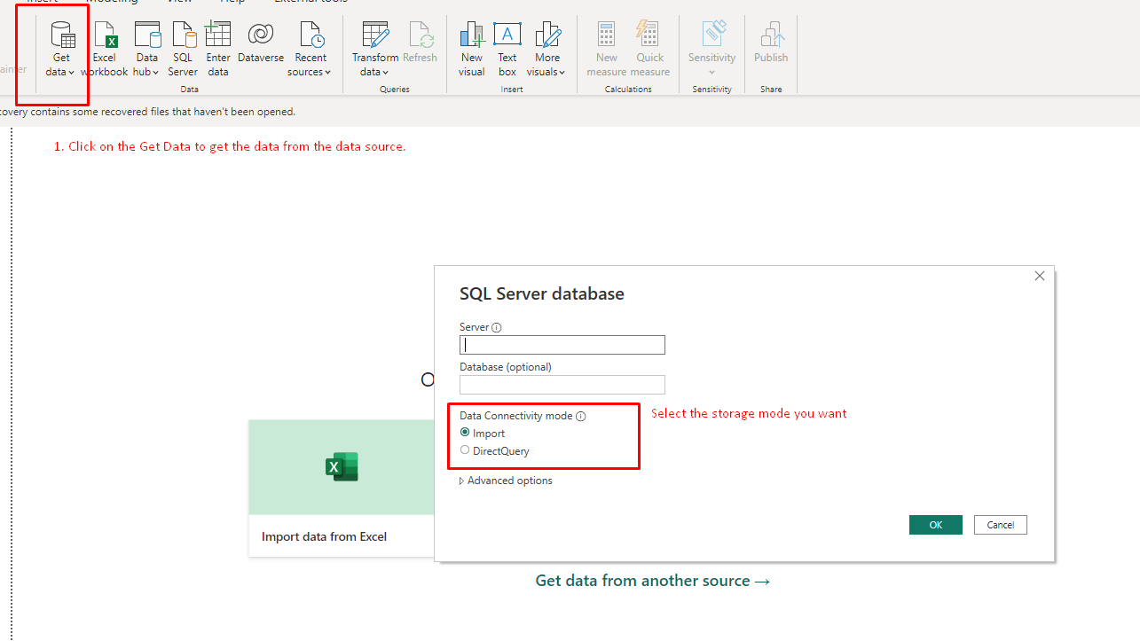

1. Any of Storage mode you choose , is set for whole dataset.

Changing the ****Storage mode**** of a table to ****Import**** is an irreversible operation. After this property is set, it can't later be changed to either ****DirectQuery**** or ****Dual****.

**Specify Storage mode for each dataset**

You can also set the storage mode property to specify storage mode for each table . also control how power bi caches you data.

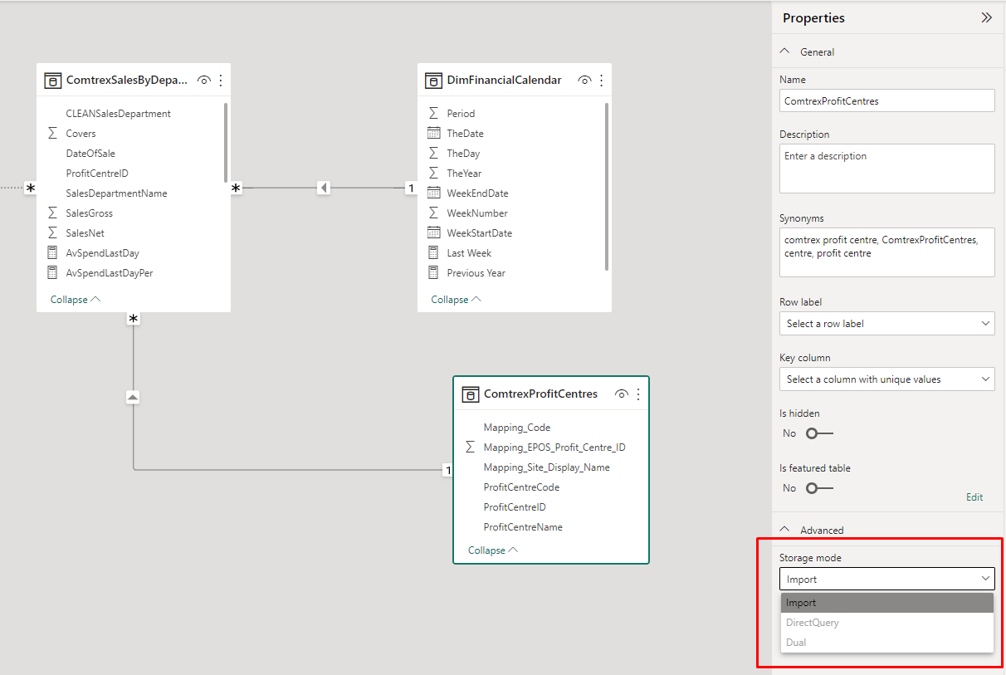

Steps to set the stoarge mode for table:

1. Go to the model view tab in power bi desktop.
2. Click on the table that you want to set the storage mode.
3. Go to the properties pane in side bar.
4. Expand the Advance option , here you can set the storage modes.
5. If you have import storage mode , then other options are disabled. Because after selecting import mode you can not switch to other storage modes.